Lab2
1. Priority scheduling non-pre-emptive
#include <stdio.h>
int main() {
int n, i, j;
printf("Enter number of processes: ");
scanf("%d", &n);
int pid[n], at[n], bt[n], pr[n];
int ct[n], tat[n], wt[n];
int completed[n];
for(i = 0; i < n; i++) {
printf("\nEnter Process ID, Arrival Time, Burst Time, Priority for process %d:\n", i+1);
scanf("%d %d %d %d", &pid[i], &at[i], &bt[i], &pr[i]);
completed[i] = 0;
}
int current_time = 0;
int completed_count = 0;
while(completed_count < n) {
int highest_priority = 9999;
int selected = -1;
for(i = 0; i < n; i++) {
if(at[i] <= current_time && completed[i] == 0) {
if(pr[i] < highest_priority) {
highest_priority = pr[i];
selected = i;
}
}
}
if(selected == -1) {
current_time++;
}
else {
int start_time = current_time;
ct[selected] = start_time + bt[selected];
tat[selected] = ct[selected] - at[selected];
wt[selected] = tat[selected] - bt[selected];
current_time = ct[selected];
completed[selected] = 1;
completed_count++;
}
}
printf("\nProcess\tAT\tBT\tPriority\tWT\tTAT\n");
for(i = 0; i < n; i++) {
printf("P%d\t%d\t%d\t%d\t\t%d\t%d\n",
pid[i], at[i], bt[i], pr[i], wt[i], tat[i]);
}
printf("Nidhi R Khabiya 1wa24cs186\n");
return 0;
}

Output
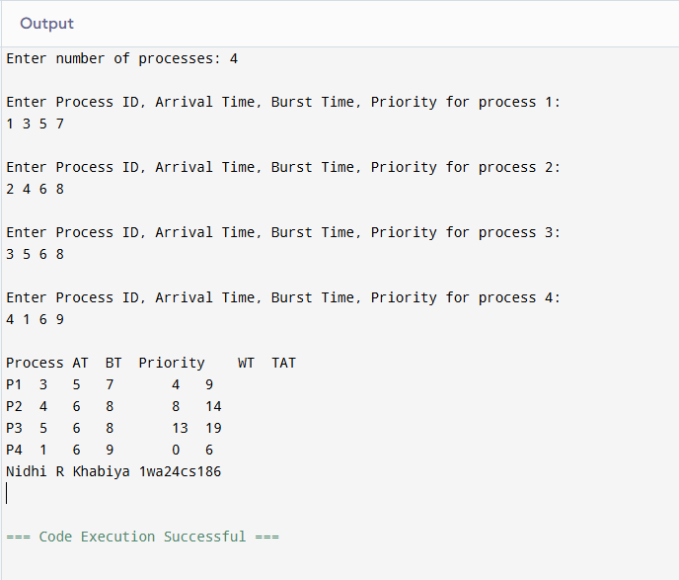

2.Priority scheduling Pre-emptive

#include <stdio.h>
int main() {
int n, i, time = 0, completed = 0;
printf("Enter number of processes: ");
scanf("%d", &n);
int pid[n], at[n], bt[n], pr[n];
int rt[n], ct[n], tat[n], wt[n];
for(i = 0; i < n; i++) {
printf("\nEnter Process ID, Arrival Time, Burst Time, Priority:\n");
scanf("%d %d %d %d", &pid[i], &at[i], &bt[i], &pr[i]);
rt[i] = bt[i]; // Remaining time = Burst time
}
while(completed < n) {
int highest_priority = 9999;
int selected = -1;
for(i = 0; i < n; i++) {
if(at[i] <= time && rt[i] > 0) {
if(pr[i] < highest_priority) {
highest_priority = pr[i];
selected = i;
}
}
}
if(selected == -1) {
time++;
}
else {
rt[selected]--;
time++;
if(rt[selected] == 0) {
ct[selected] = time;
tat[selected] = ct[selected] - at[selected];
wt[selected] = tat[selected] - bt[selected];
completed++;
}
}
}
printf("\nProcess\tAT\tBT\tPriority\tWT\tTAT\n");
for(i = 0; i < n; i++) {
printf("P%d\t%d\t%d\t%d\t\t%d\t%d\n",
pid[i], at[i], bt[i], pr[i], wt[i], tat[i]);
}
printf("Nidhi R Khabiya 1wa24cs186\n");
return 0;
}

Output
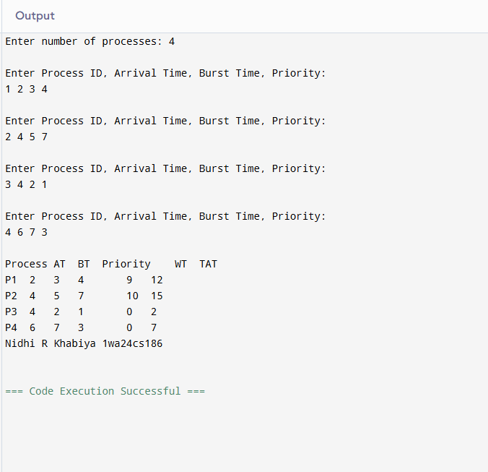

3. Round Robin

#include <stdio.h>
int main() {
int n, tq, i;
printf("Enter number of processes: ");
scanf("%d", &n);
int pid[n], at[n], bt[n], rt[n];
int wt[n], tat[n], ct[n];
printf("Enter Time Quantum: ");
scanf("%d", &tq);
for(i = 0; i < n; i++) {
printf("\nEnter Process ID, Arrival Time, Burst Time:\n");
scanf("%d %d %d", &pid[i], &at[i], &bt[i]);
rt[i] = bt[i]; // Remaining time
wt[i] = 0;
tat[i] = 0;
}
int completed = 0, current_time = 0;
float total_wt = 0, total_tat = 0;
while(completed < n) {
int executed = 0;
for(i = 0; i < n; i++) {
if(at[i] <= current_time && rt[i] > 0) {
executed = 1;
if(rt[i] > tq) {
current_time += tq;
rt[i] -= tq;
}
else {
current_time += rt[i];
ct[i] = current_time;
tat[i] = ct[i] - at[i];
wt[i] = tat[i] - bt[i];
total_wt += wt[i];
total_tat += tat[i];
rt[i] = 0;
completed++;
}
}
}
if(executed == 0) {
current_time++;
}
}
printf("\nProcess\tAT\tBT\tWT\tTAT\n");
for(i = 0; i < n; i++) {
printf("P%d\t%d\t%d\t%d\t%d\n",
pid[i], at[i], bt[i], wt[i], tat[i]);
}
printf("\nAverage Waiting Time = %.2f", total_wt/n);
printf("\nAverage Turnaround Time = %.2f\n", total_tat/n);
printf("Nidhi R Khabiya 1wa24cs186\n");
return 0;
}

Output
